Contents

Creating the page 3

Classic team site 3

1.1.Site page 3

1.2.Edit the Page 3

1.3.Site collection 4

Root site and sub site 4

Default page 5

1.4. Site Setting 5

**Search** 6

1.Look and Feel 6

Composed looks 6

Lists Template 7

Site Columns 8

Add two columns at 9

Content Type 10

Create new content type 10

**Manage site features:** 11

Used to change site features 12

Regional Settings 13

Language Settings 13

Site Libraries and Lists 13

Sites and Workspaces 14

Site Closure and Deletion 14

Site Collection Administration 15

Recycle Bin 15

Edit the top links 16

Create subsite 16

Site content 17

Top link navigation 18

Web Part 19

Insert Content Table 19

Site and workspace 20

Create Blog as a Template 21

Create a post 21

2. Project site 21

3. Badge 22

Create Badges 22

Assign Badges to members 22

**Class 8**

|  |
| --- |
| 1. Create departmentA under Department but sub site under Templates is disable.   Case 1:  Setting=>site content=>app=>sub site  Case 2:  Setting=>site setting=>site and work space   1. Why we choice Project site for our Department which has tasks, calendars . . . better than team site? 2. For which subsite publish site we use?   **Quetions**   1. Q1.Create List as a Template/ Save site as a Template? 2. Q2. Create a workspace? 3. That Means create a subsite? But in site content way there is no subsite button. In that time we Sites and Workspaces 4. follow 5. Q4. Enabling **Document site? We do this either Site Collection Administration or** [**Manage site features**](https://eyos2011.sharepoint.com/sites/Demo/_layouts/15/ManageFeatures.aspx) |

# Creating the page

## Classic team site

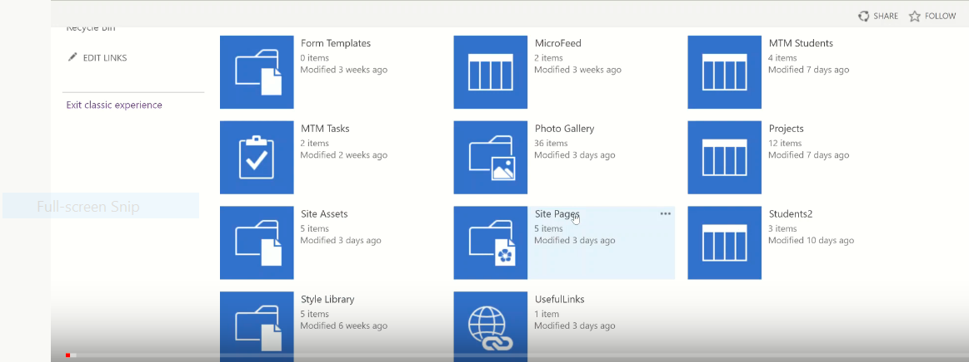

1.1.Site page**:**

Site page=>web part page : which is not editable on its page.

Other than using (Setting=>Edit page **or** File=>Edit page)=>add web part

1.2.Edit the Page**:**

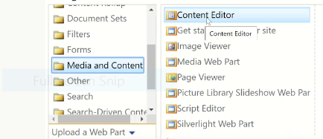

**Then we get**

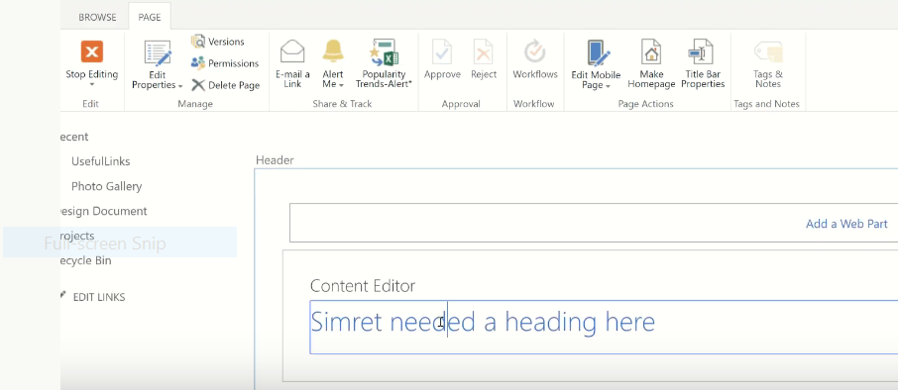

**To remove Content Editor from the page(**make content Type**: None=>apply)**

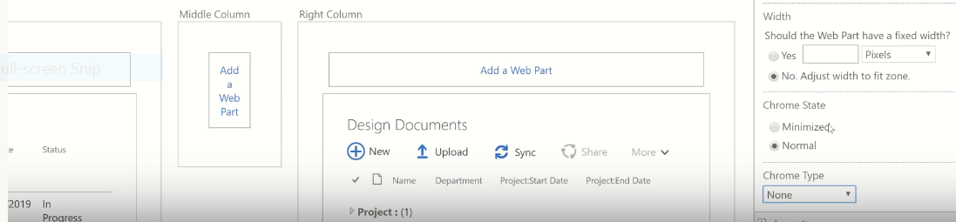

## 1.3.Site collection

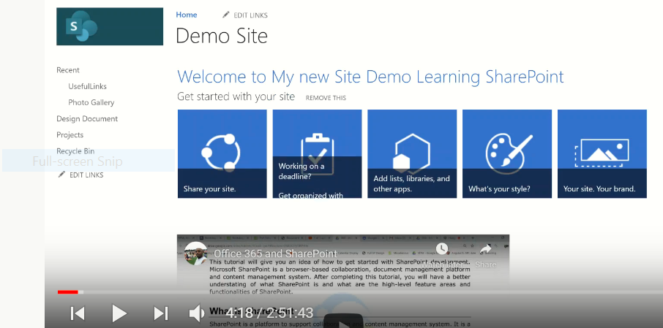

**Remember the beginning**

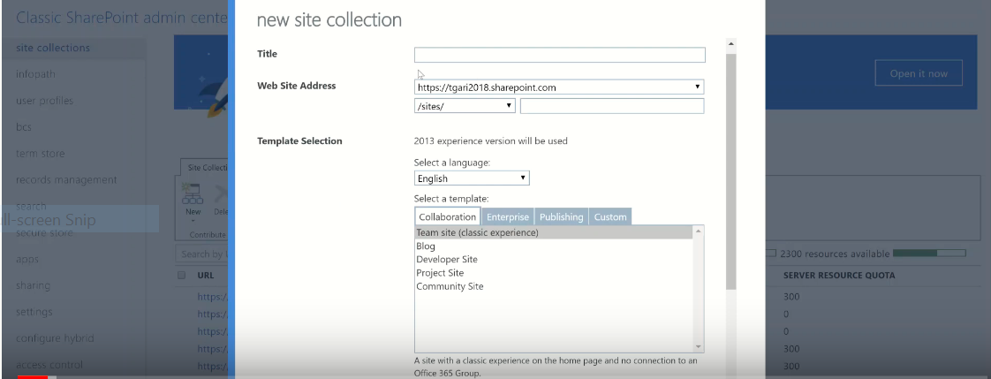

### Root site and sub site

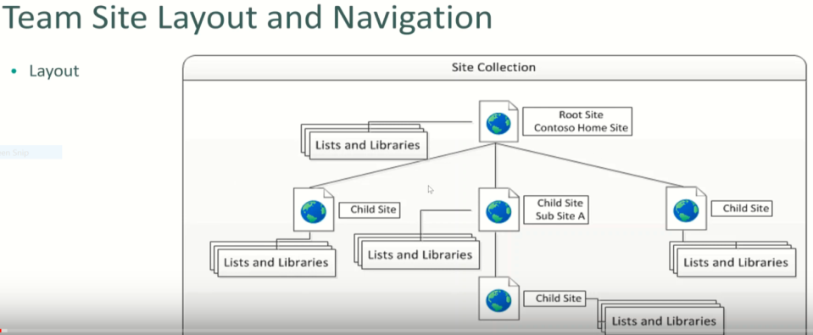

Eg.

MyFirstWebPartPage

Setting=>Site content=>Site page

### Default page

Is the page that exists when we doing the URL

**Eg.1: Identify existing default pages**

When we put: <https://eyos2011.sharepoint.com/sites/Demo/>

We get: <https://eyos2011.sharepoint.com/sites/Demo/SitePages/Home.aspx>

So that: **Home** is our default page under Site Page.

**Eg.2: Creating New default pages**

By using setting=>site content=> Site pages=>MyFirstWebPartPage

=>PAGE=>Make HomePage

**Then it will be default page.**

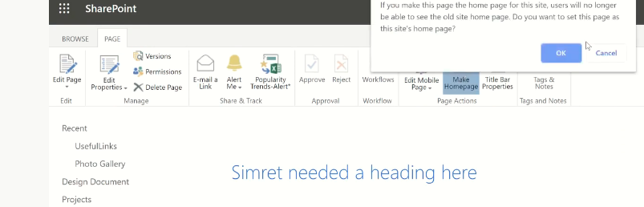

* 1. Site Setting**:**

|  |  |  |
| --- | --- | --- |
| **1** | **Users and Permissions** |  |
| **2** | **Look and Feel** | [**Title, description, and logo**](https://eyos2011.sharepoint.com/sites/Demo/_layouts/15/prjsetng.aspx)**=>Title(Demo)=>From computer=>** |
| **3** | **Web Designer Galleries** |  |
| **4** | **Site Actions** |  |
| **5** | **Site Administration** |  |
| **6** | **Site Collection Administration** |  |
| **7** | **Search** |  |

1.Look and Feel**:**

* [**Title, description, and logo**](https://eyos2011.sharepoint.com/sites/Demo/_layouts/15/prjsetng.aspx)**=>Title(Demo)=>From computer=>**
* [**Change the look**](https://eyos2011.sharepoint.com/sites/Demo/_layouts/15/designgallery.aspx)**=>**

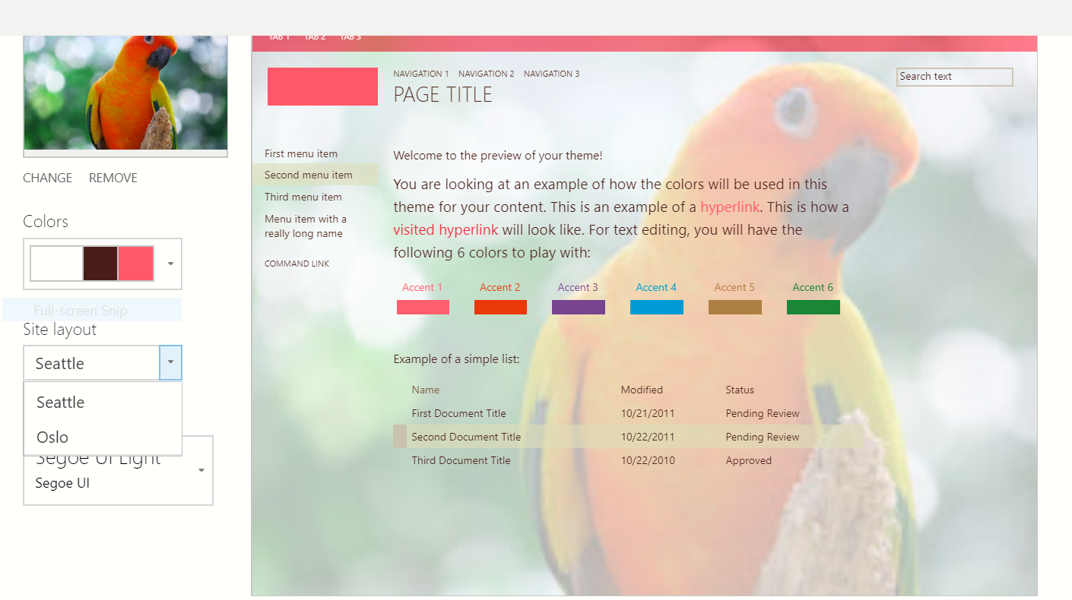

**Then try out=>yes,keep it/No**

### Composed looks

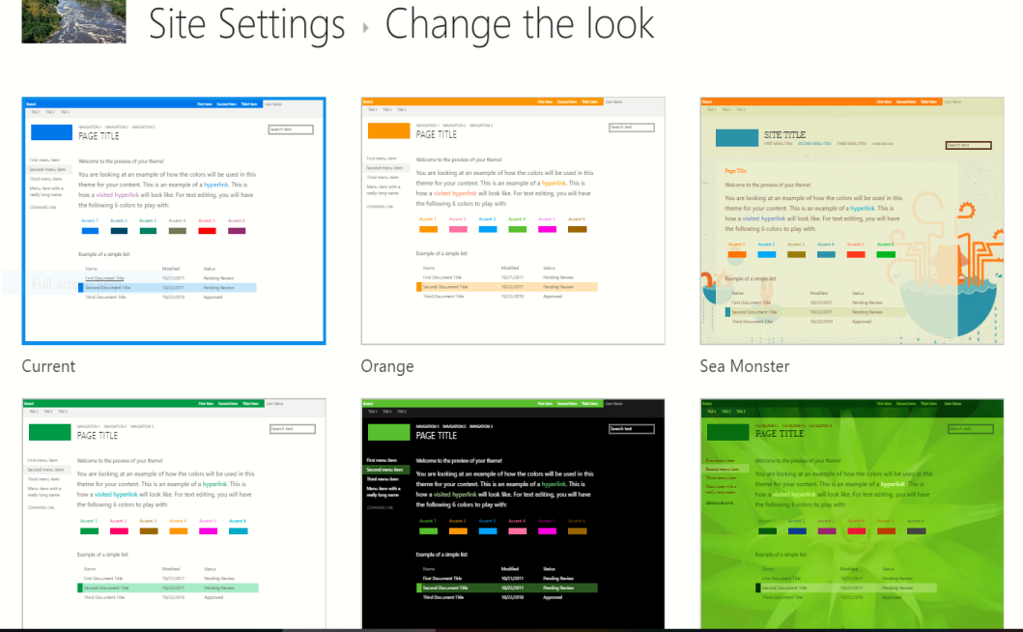

**Web Designer Galleries=>composed looks**

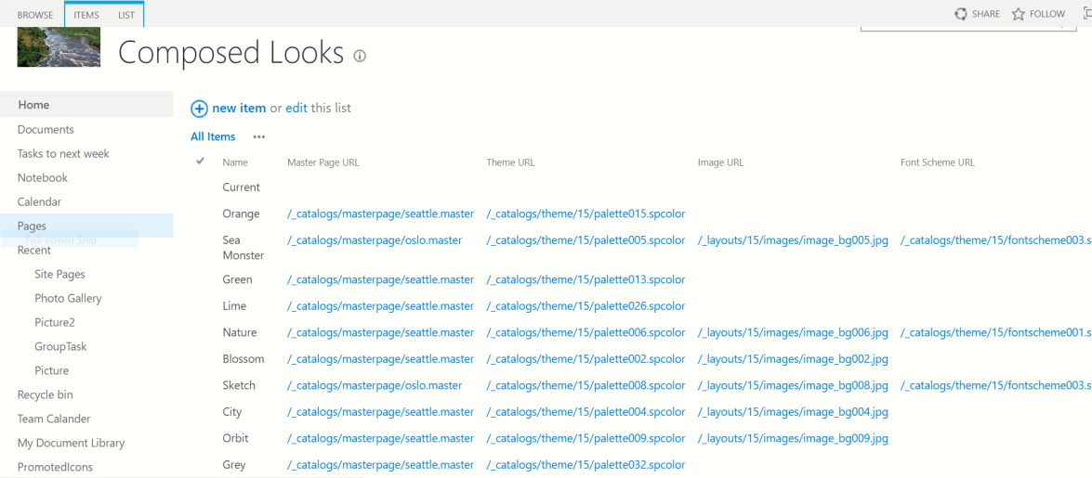

### Lists Template

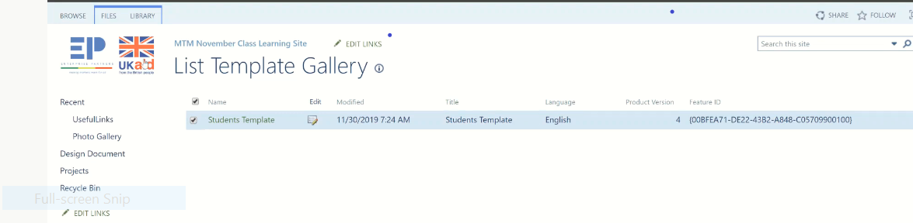

**Under Site Action:**

Save site as a Template=>

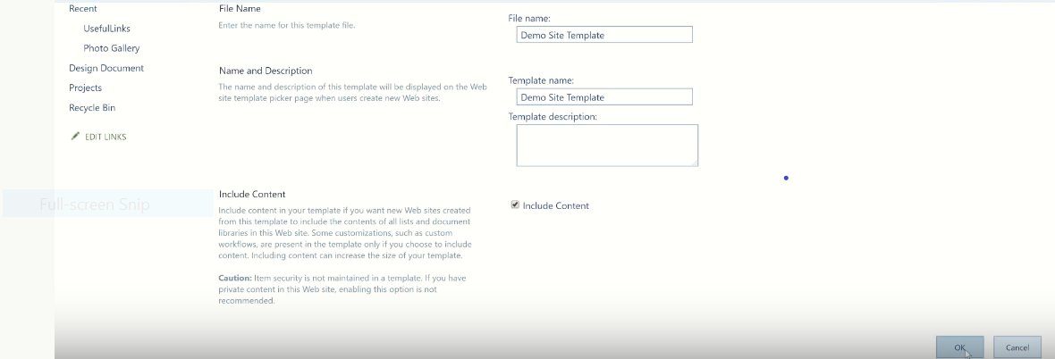

**Look the result**

Solution=>

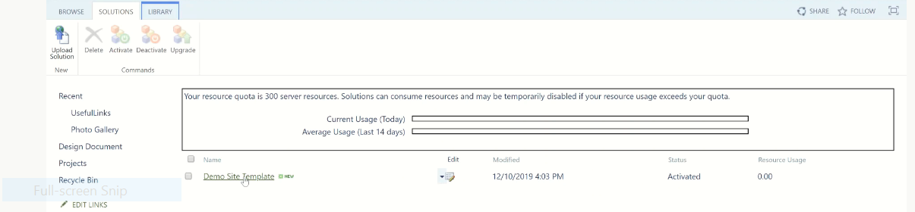

Then select=>deactivate

Site Columns**:**

Changing something inside it everywhere changed

Create=>Name(XX)=>choice

Compare two way columns

|  |  |
| --- | --- |
| Site content way | Site setting way |
| |  | | --- | | Single line of text | |  | Multiple lines of text | |  | Choice (menu to choose from) | |  | Number (1, 1.0, 100) | |  | Currency ($, ¥, €) | |  | Date and Time | |  | Lookup (information already on this site) | |  | Yes/No (check box) | |  | Person or Group | |  | Hyperlink or Picture | |  | Calculated (calculation based on other columns) | |  | Task Outcome  //////////////////////////// | |  |  | |  | External Data | |  | Managed Metadata | | |  | | --- | | Single line of text | |  | Multiple lines of text | |  | Choice (menu to choose from) | |  | Number (1, 1.0, 100) | |  | Currency ($, ¥, €) | |  | Date and Time | |  | Lookup (information already on this site) | |  | Yes/No (check box) | |  | Person or Group | |  | Hyperlink or Picture | |  | Calculated (calculation based on other columns) | |  | Task Outcome  //////////////////////////// | |  |  | |  | Full HTML content with formatting and constraints for publishing | |  | Image with formatting and constraints for publishing | |  | Hyperlink with formatting and constraints for publishing | |  | Summary Links data | |  | Rich media data for publishing | |  | Managed Metadata | |

* Site setting=>site columns=>create=>name(MTMDepartment)=>New group(MTM Columns)=>Choice(IT,sales,customer service,marketing)=>default value empty=>
* To add additional columns: use everything the same the only difference is Select
* MTM Columns From existing
* Choice(Not started, pending,compeleted)
* Select the default value

### Add two columns at

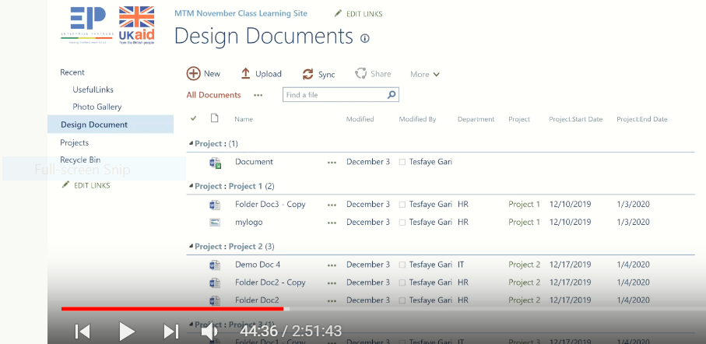

|  |
| --- |
| Library=>Library setting=>  **=>**[Add from existing site column](https://eyos2011.sharepoint.com/sites/Demo/_layouts/15/AddFieldFromTemplate.aspx?List=%7B3C6F8B95%2D34CA%2D4079%2DBB2F%2D613E57C69A38%7D) |
|  |
| https://eyos2011.sharepoint.com/_layouts/15/images/setrect.gif?rev=47 |

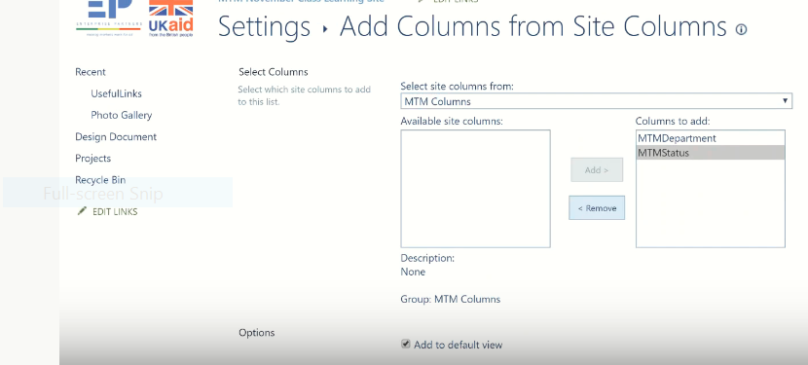

Ok, then we get

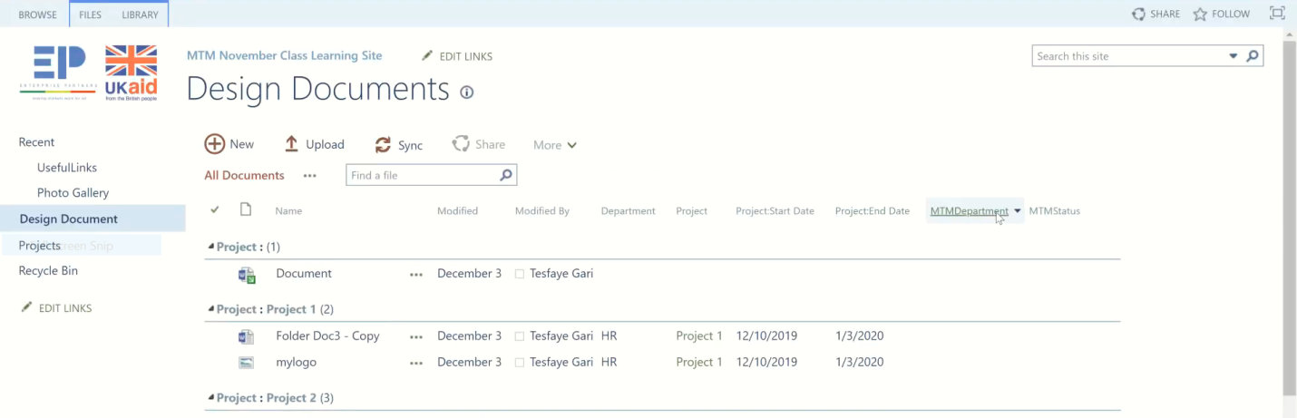

Content Type**:**

Is agroup of columns

Library=>Library setting=>Content Type, but we didn’t find it b/se

Content Type is off in Advanced setting. So make on it. After that we get Document content type.

Every single content type has parent

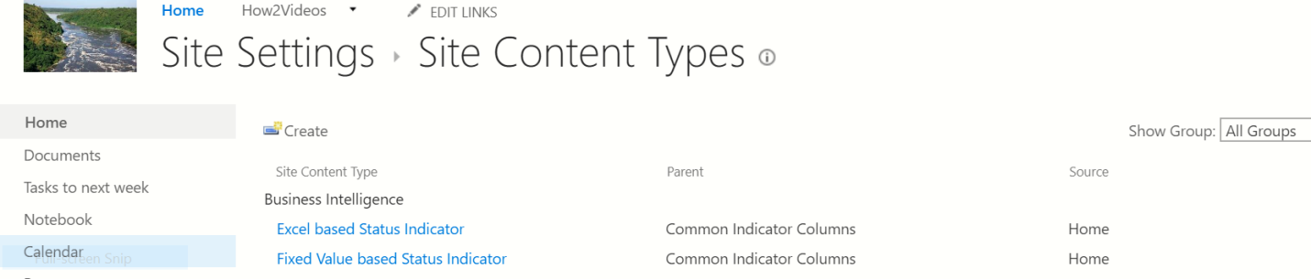

Create new content type**:**

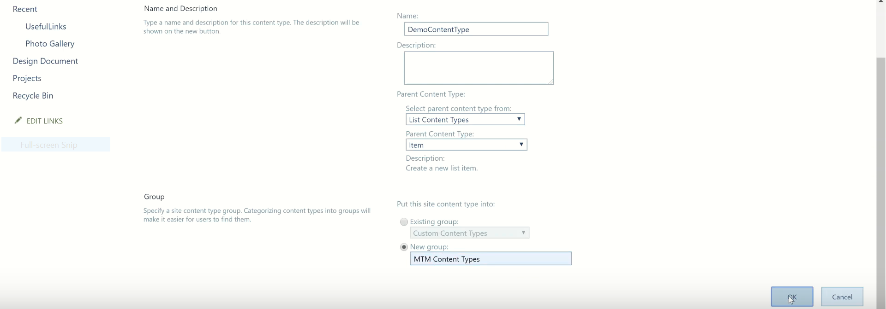

Then we get

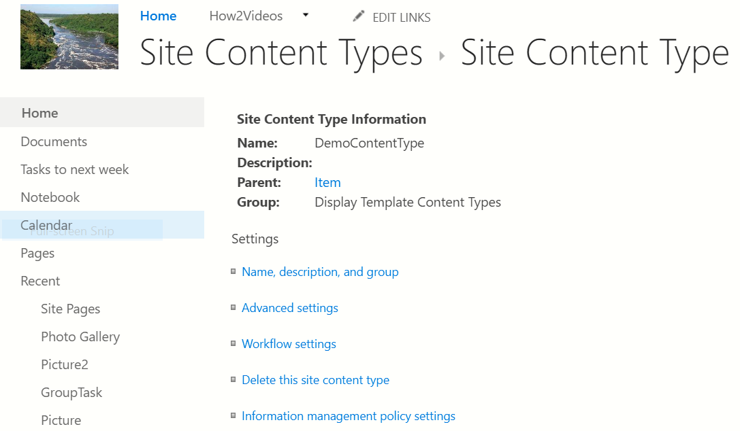

[Manage site features](https://eyos2011.sharepoint.com/sites/Demo/_layouts/15/ManageFeatures.aspx)**:**

Used to change site features

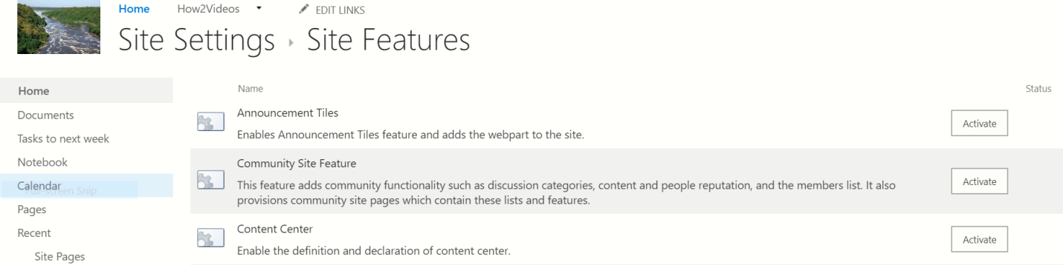

It used to activated

Eg.

Then we get the above **site features.**

If the right top share and follow are disable make enable

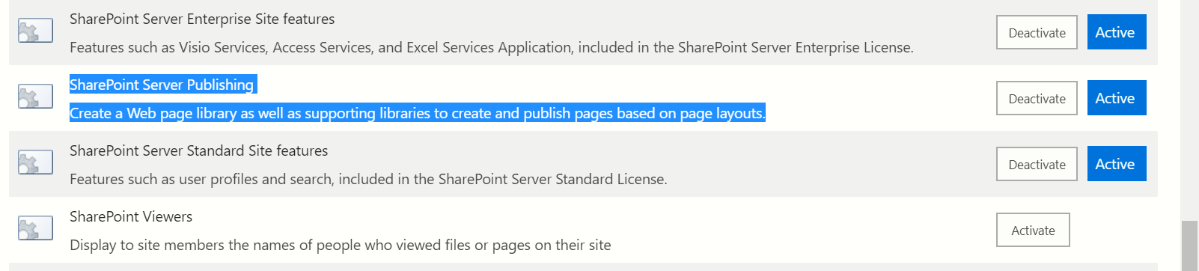

# Regional Settings

Used to change currency.

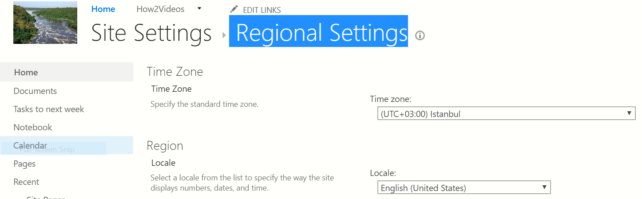

## Language Settings

Used to change Language.

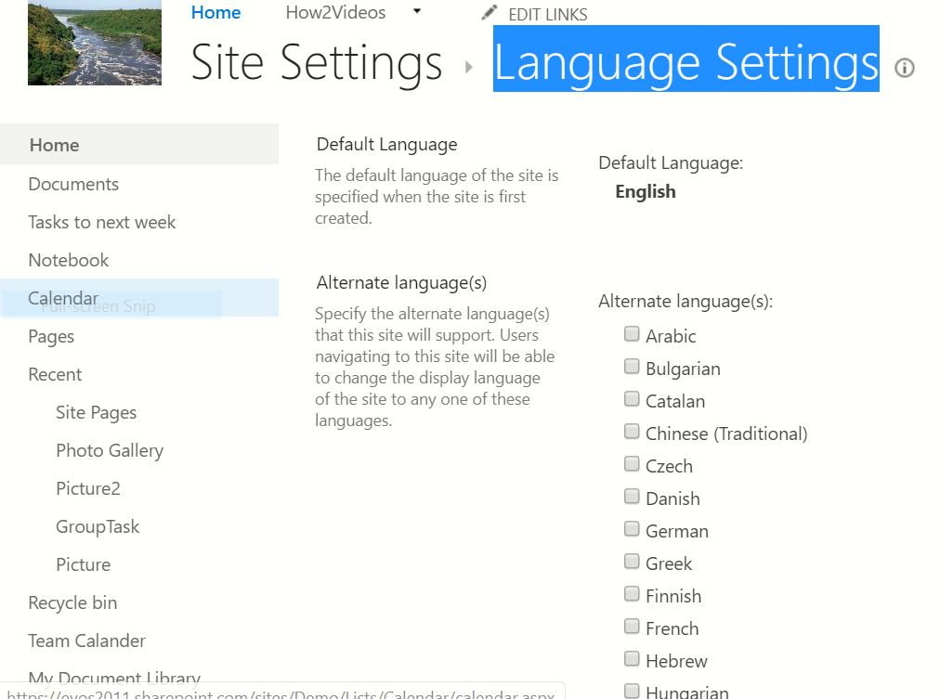

## Site Libraries and Lists

To show all libraries and lists

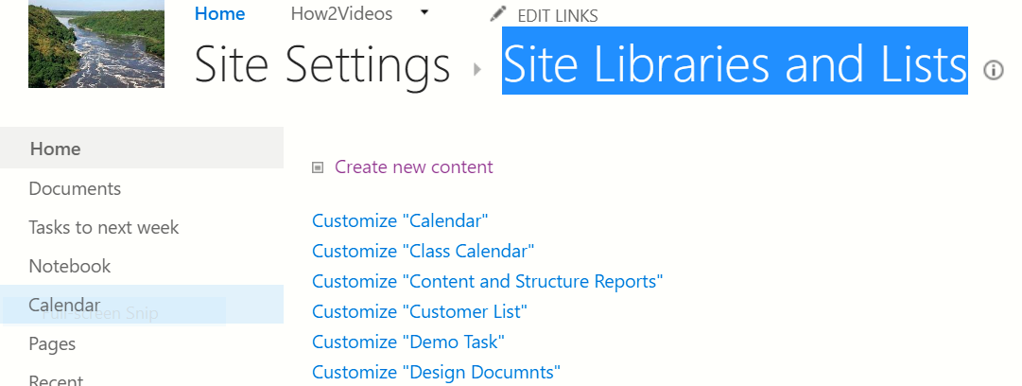

## Sites and Workspaces

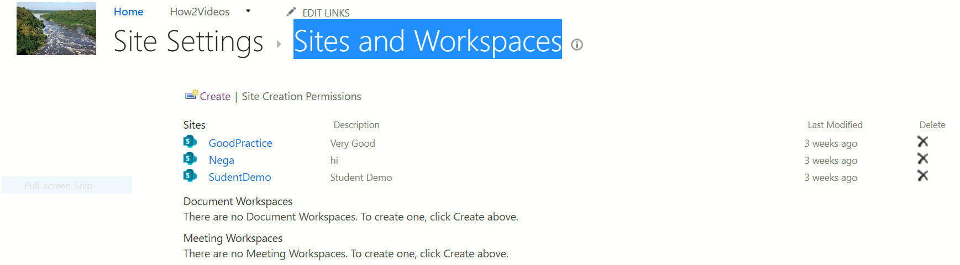

## Site Closure and Deletion

Policy cration for deletion purpose.

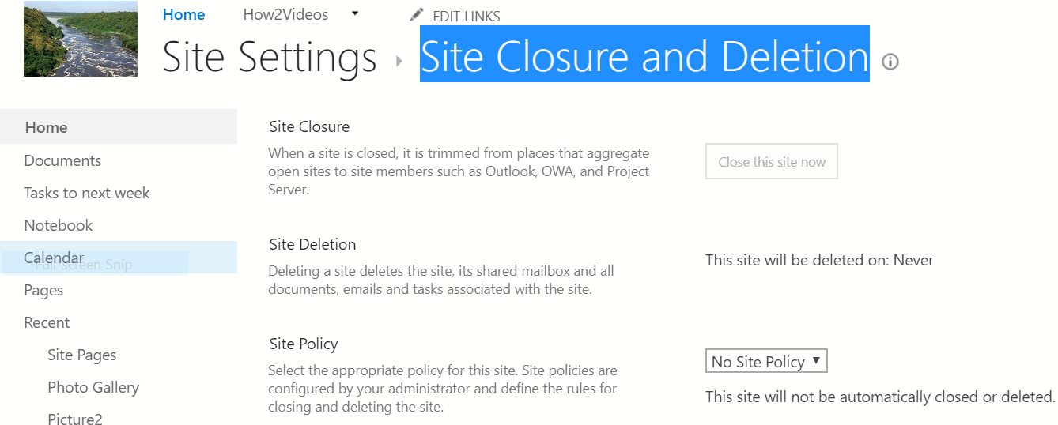

## Site Collection Administration

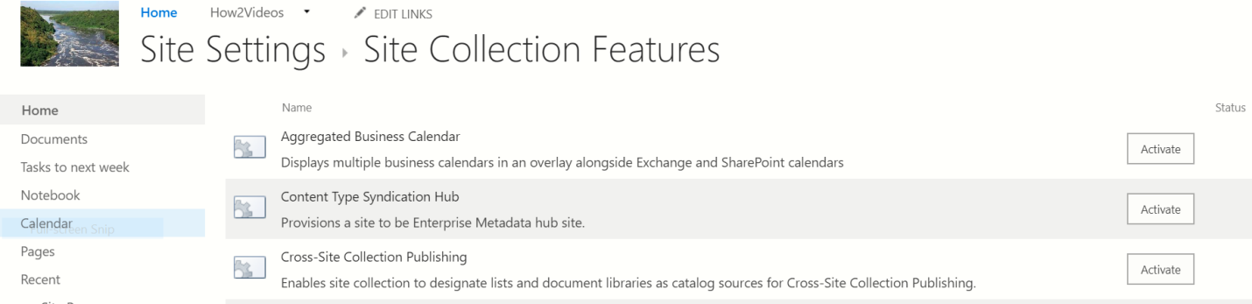

Enabling **Document set is here.**

# Recycle Bin

To recover deleted Document.

It is not work for edited Document, this recover by versioning on.

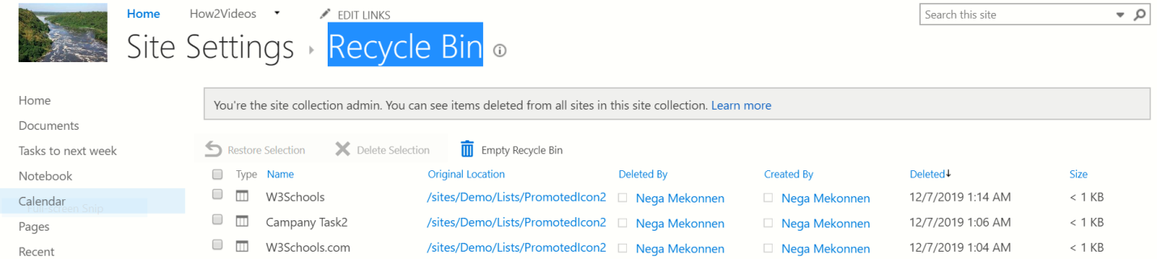

Site content=>New Subset

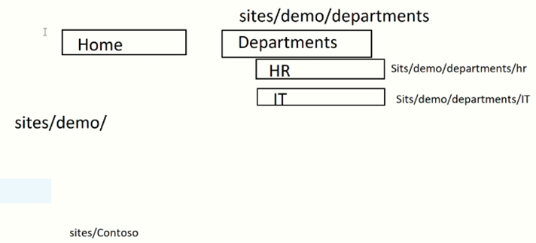

**NB:Assignment**

# Edit the top links

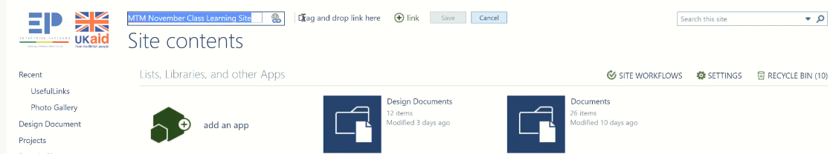

The URL is not changed only **Home to MTM November Class training site**

Create subsite**:**

Departments: under **Template site**

* Create subsite Blog Under blog site
* Create subsite Sale Under project site
* Create subsite comunity Under community all of them are asubset of Departments
* 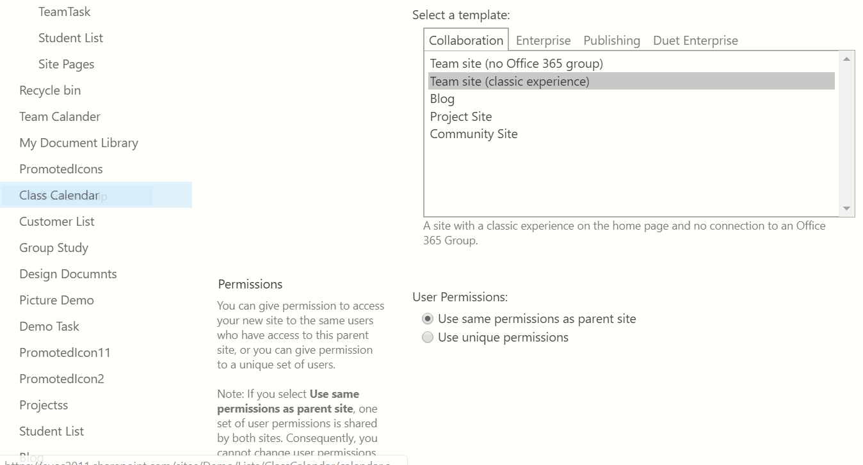

**Case 1:** site content=>subsite

**Case 2:** **Setting=>site setting=>Sites and Workspaces=>create. We get the same result on both steps.**

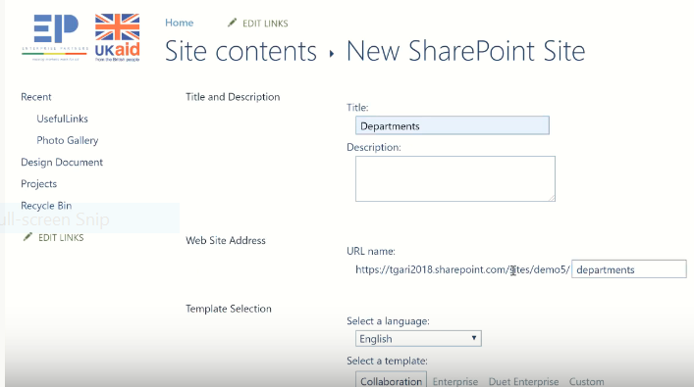

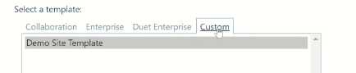

Demo Site Template = is saved site

**Subsite: Department**

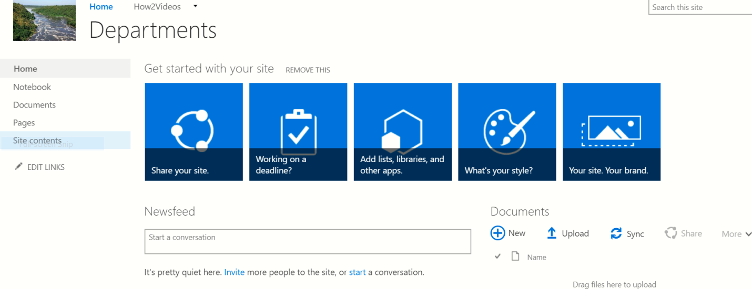

### Site content

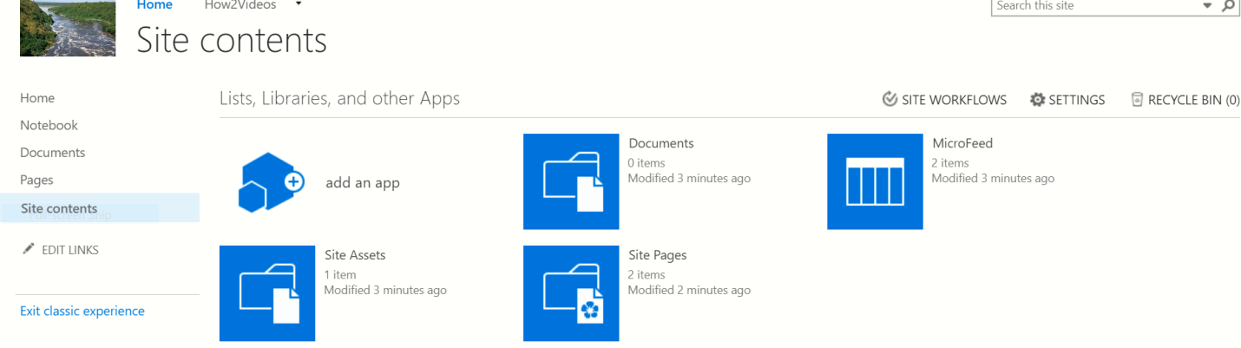

Check it at the root site(Demo)

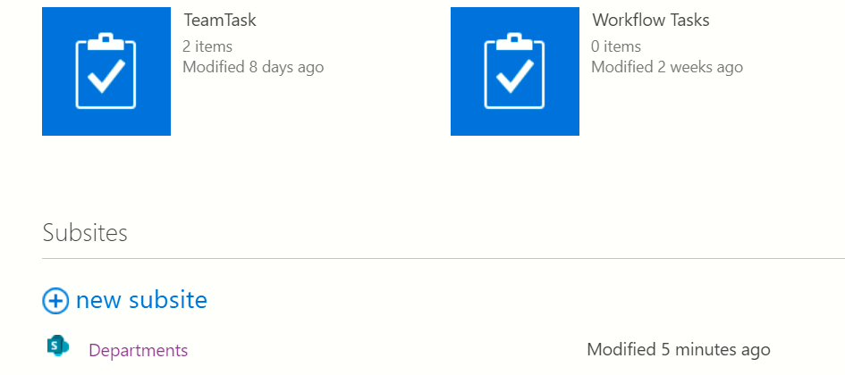

#### Bolg

<https://eyos2011.sharepoint.com/sites/Demo/departments/_layouts/15/viewlsts.aspx>

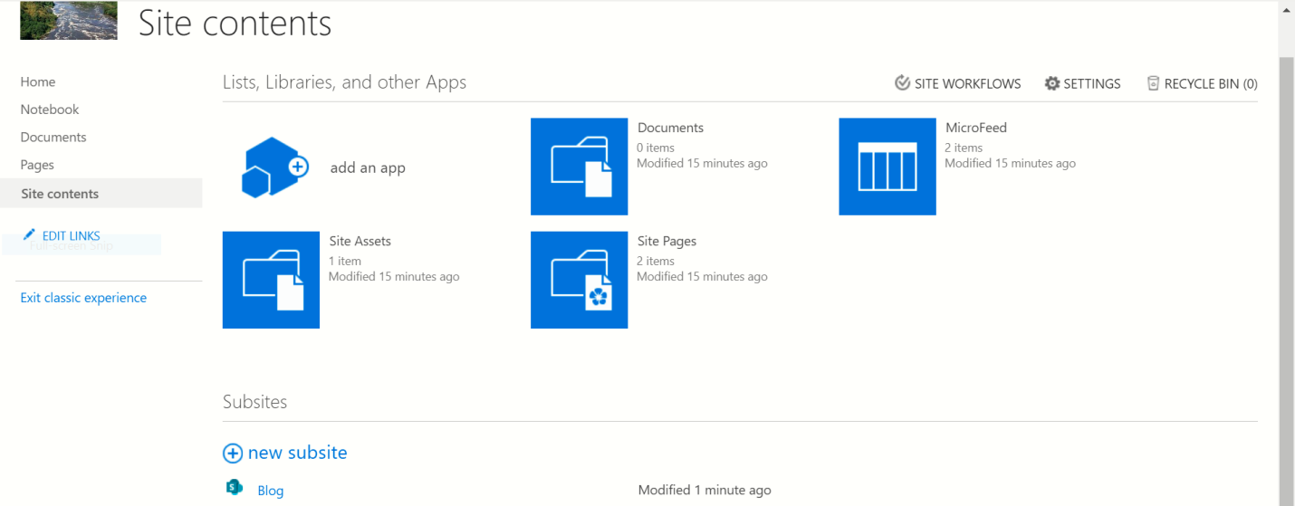

## Top link navigation

To manage the top link Navigation : site setting=>Navigation

**You Know How To Show Subsite:** Open libtaty(Department)=>setting=>site setting=>navigation=>show subsite

**NB**: We get Navigation in all subsites b/se we enable site collectin feature at root site.

# Web Part

Open Department=>Edit at the right top=>

**To make space on the page:**

select the page=>

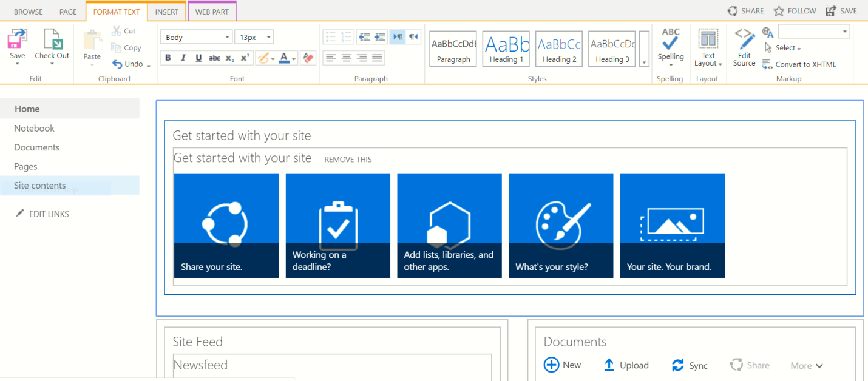

=>Edit source=>enter the URL 1 or 2 steps down=>ok

# Insert Content Table

* Web part=>content Roll up=>Table of content=>Add
* **Remove** the Templates edit it at the right side of the page

#### Excerses:contoso

**Colaboration>>Team site(Classic experience)**

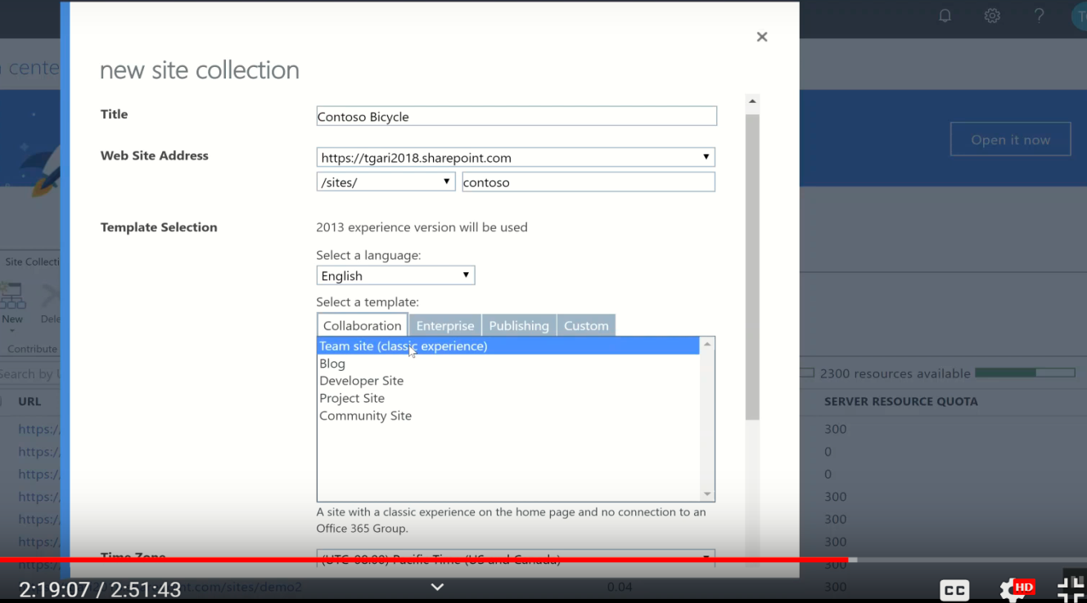

**Time zone** : UTC-5

Make it “BookMark” , then we do our Ex on it.

## Site and workspace

**Setting => site setting =>Sites and Workspaces**

1. **Blog** :Create a news and comment on it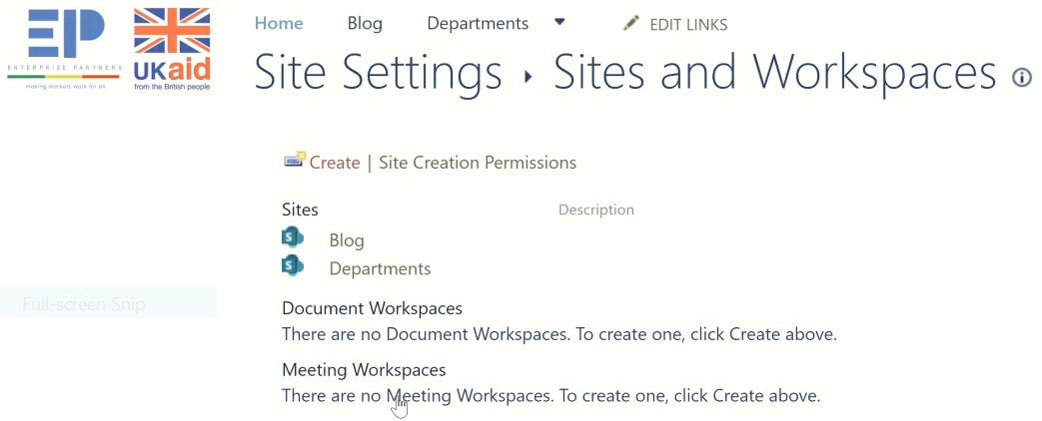

* Which kind of features they follow
* May they need blogs
* research
* Knowledge able articles

Create Blog as a Template**:**

**Blog =>**

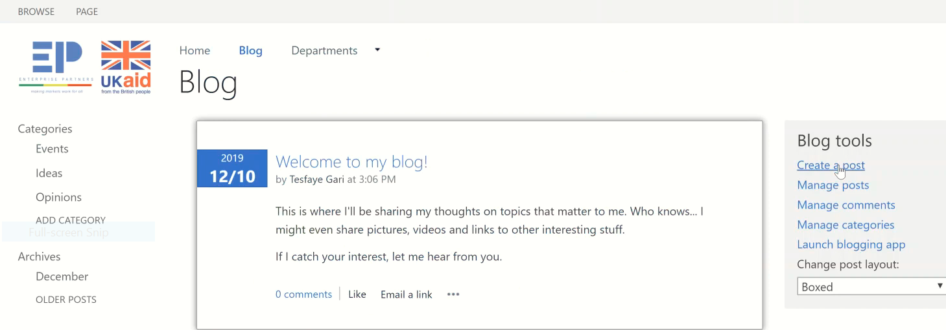

### Create a post

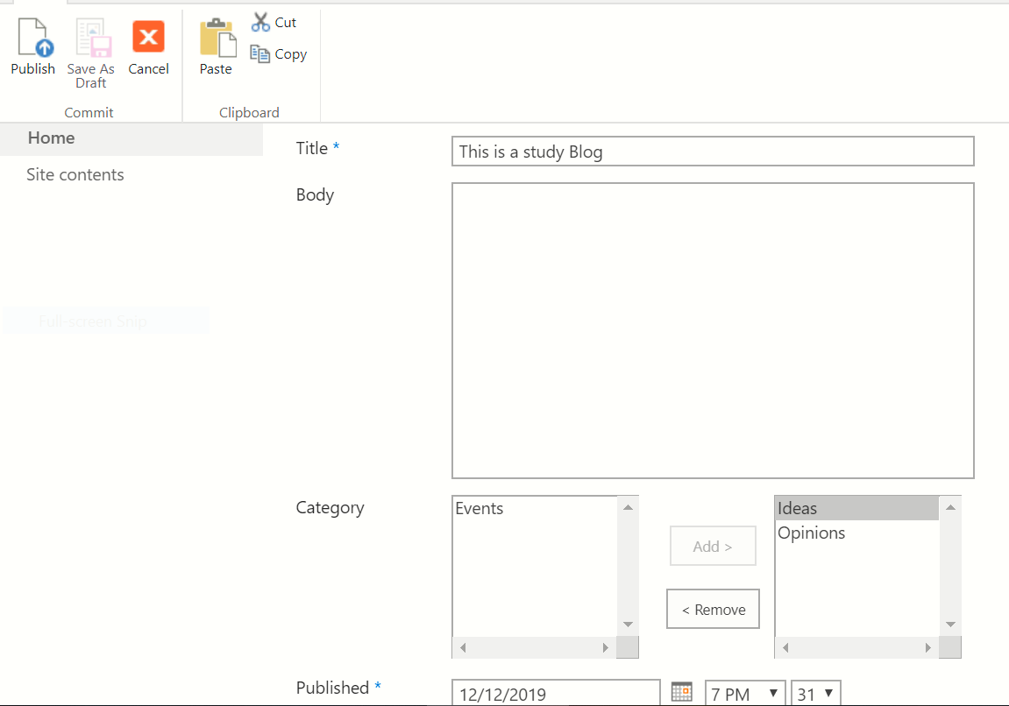

Then Publish=>

1. Project site: If you want to create site for your Department: project site is the right choice. Before we choose it we see **Clue to justify:**

Ask ourselves/peoples: **What kind of things contains your Department?**

* **Tasks**
* **Calendar and etc**

This is clue to choose **project site** rather than **team site**.

B/se we don’t want to start from scratch, **project site** has:

* Event
* Tasks
* Calendar
* All of the Documents
* May be we add a couple of other Lists and stuffs.

1. Badge**:**

Create Badges**:**

Community subsite under Department (Sale) => open it => Create Badge => Name(Gold Badge) => Save

Assign Badges to members**:**

**Open site again => Assingnment Badge =>Moderation => Give Badge => select the Badge name** =>

**Go to the top level site settings from sale site:**

Setting=>site setting=> Go to the top level site settings, the we get

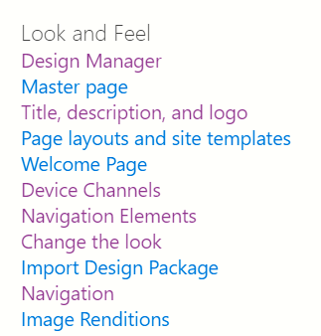

**So after 3/2 month we will talk about:**

[**Design Manager**](https://eyos2011.sharepoint.com/sites/Demo/_layouts/15/RedirectPage.aspx?Target=%7bSiteCollectionUrl%7d%7bLayoutsFolder%7dDesignSite.aspx)**,** [**Device Channels**](https://eyos2011.sharepoint.com/sites/Demo/_layouts/15/RedirectPage.aspx?Target=%7bSiteCollectionUrl%7dDeviceChannels)**,** [**Import Design Package**](https://eyos2011.sharepoint.com/sites/Demo/_layouts/15/DesignPackageInstall.aspx)in short about add one

**////////////////////////////////////////////////////**

**Ed of Class 8**

**For the next**

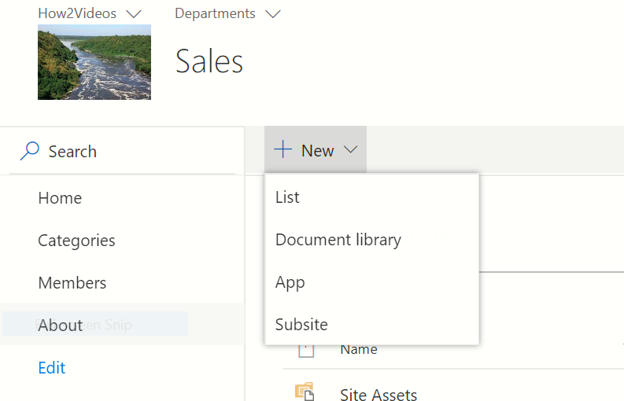

**Publishing site: for only Root site**

